ISM 6405

Final Exam, Summer, 2016

Your final is a bit of a project. Parts of it allow you to create a form of a dashboard for your user. Using the data files given in the accompanying workbook (cleverly named Data for ISM 6405 Final Exam Summer 2016.xlsx), first create a three page multi-page UserForm that allows a user to select a page and create the following analysis of the data shown below. Then answer the last three questions in the same workbook, just not using the UserForm. While there are 7 questions here, only first three are to be accessed using the MultiPage UserForm. Also keep in mind that you can create your own subs and functions in the code window for a UserForm. As this is also a learning exercise, please do not hesitate to contact me if you need explanation about a question or get hung up in some processing error. Everything you are being asked to do has been explained in the Videos created for each week or in the textbooks.

As usual, please include a statement to the effect that you worked alone on this project. Your completed submission is due by 11:59 pm on Sunday, August 7.

**Question 1**. (10 Points) Under a tab named **Statistics** and using the data found on the **Stats** worksheet, allow the user to select the data, and then display in a MsgBox these statistics:

a. The average of the selected data

b. The standard deviation of the selected data

c. The largest value in the selected data

d. The smallest value in the selected data

e. The median of the selected data

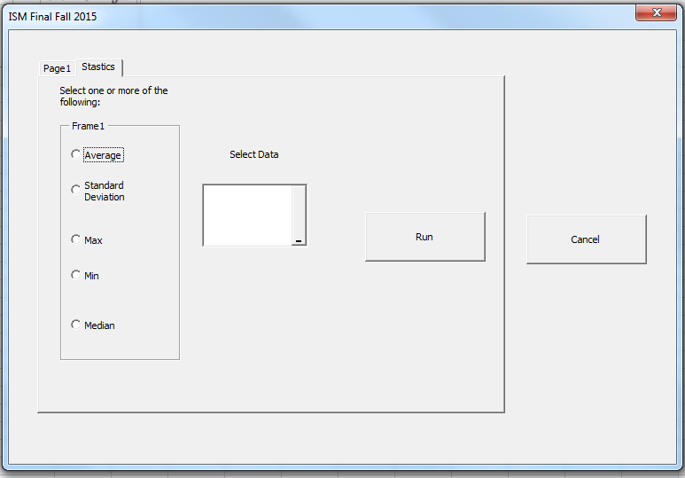

Note: the examples are NOT on a 3 page MultiForm. Your answers should all be on one 3 page form.

**Question 2.**  (20 Points) Under a tab named **Get Data** and using the **Retrieve Data** worksheet, allow the user to select one of three stocks (IBM and two others of your choice). The system will then access Yahoo.com and downloads only the information in the table below (while the sample data below is shown for illustrative purposes, the user should be able to click on any of the three option button and retrieve the data that is current for the stock selected at the time it is run). Hint, first record a macro called IBMMacro using the page where you will display your stock information. Once that is running and cleaned up, repeat for the other two stocks. Have three active options buttons for retrieving information about stocks.

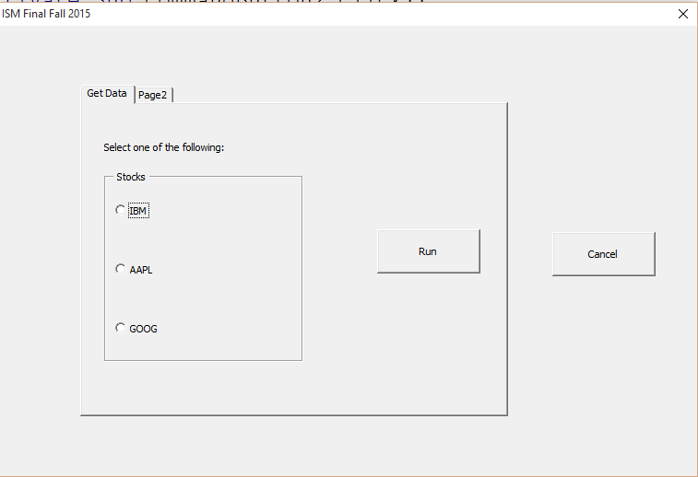

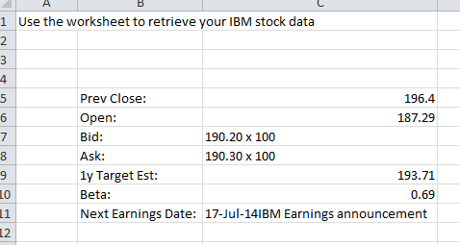

This is the format for your Retrieve Data worksheet. The data shown is for illustrative purposes only. Your results should be current at the time of retrieval for each stock.

**Question 3**. (20 Points) Under the **Charts** tab and using the data found on the **ChartData** worksheet, allow the user to display one of three charts of their choice the data from the **ChartData** worksheet as an image in the UserForm. The example shown uses the **xlPie** for the chart type. You are to use the three chart types shown in the illustration.

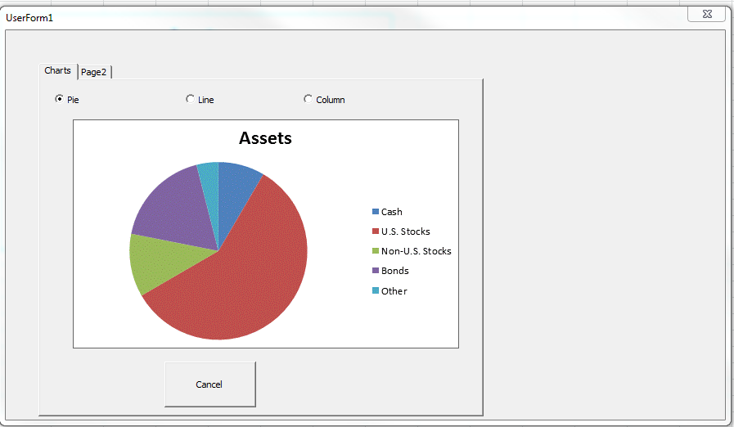

**Question 4.** (20 points) This question does not have to be placed in the Multiform you created for the first three parts of the exam. The **CollegeData Worksheet** tells you the following information about students who applied to graduate school at State University: gender, desired major, whether accepted or rejected. Using PivotTables, as your analytic tool, do you think State University discriminates against men? Why or why not? Place your analysis of this data on the same worksheet as your pivot tables.

**Question 5**. (10 Points) This question does not have to be placed in the Multiform you created for the first three parts of the exam. The **DowData worksheet** contains the monthly returns between the 30 stocks comprising the Dow Jones Index. Create a correlation matrix for the stocks. Then, for each stock, use conditional formatting to highlight the three stocks most correlated with that stock. Do not highlight the stock correlations with itself. You will need to create a new rule for the conditional format which uses a formula and probably includes an “AND” and a “LARGE” function). Place your analysis of this data on the same worksheet as the data.

**Question 6**. (10 Points) You are planning on setting up a 529 College Savings Plan. You anticipate being able to invest $4,000 per year and want to know the amount of money you will have in the 529 fund using annual rates of return on your investment from 2 percent through 10 percent after saving for 10 to 18 years. Use a data table approach in your solution.

**Question 7**  (10 Points) Identify 5 improvements that should be made in the Excel dashboard (shown below) that was presented under Blackboard week 12 materials. Your answer should be in sentence form and both state what is incorrect and how you would improve it.

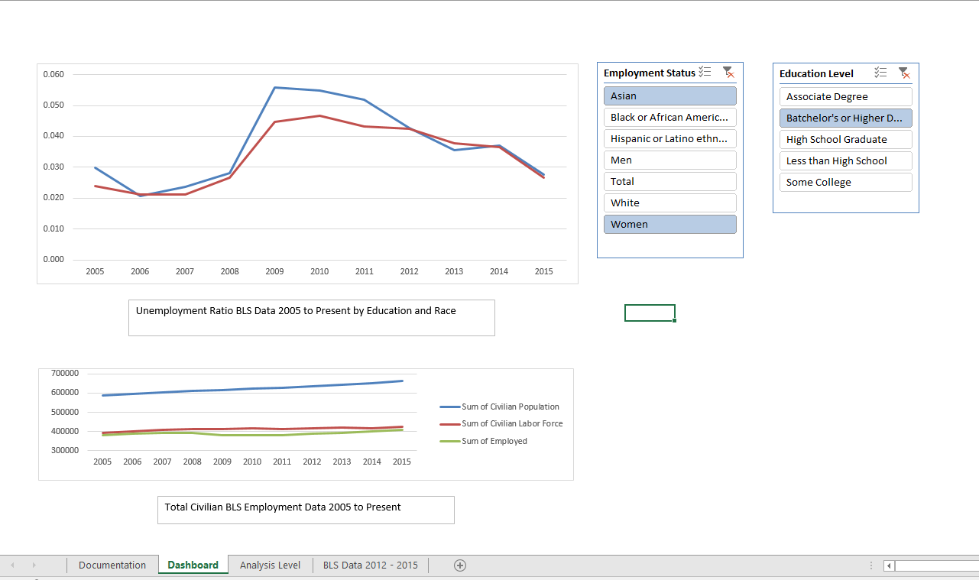

Please turn in your completed workbook renamed as **Final Summer 2016** just as you would any homework file.

I enjoyed working with each of you this semester and wish you all the best with your studies and every success in your future careers. Go Owls !